**Docker Installation on Ubuntu**

**Commands Used in order of execution:**

1. sudo apt update
2. sudo apt install docker.io -y
3. sudo systemctl enable docker
4. sudo systemctl start docker
5. docker --version

**Screenshots of the Installation Process:**

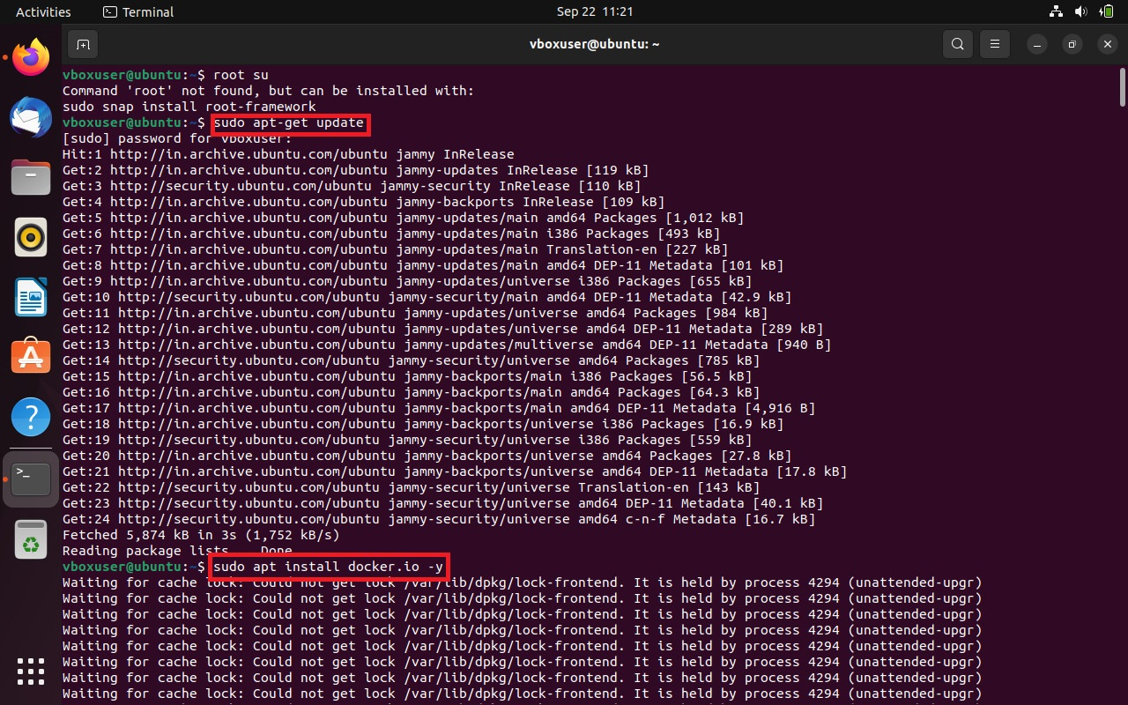

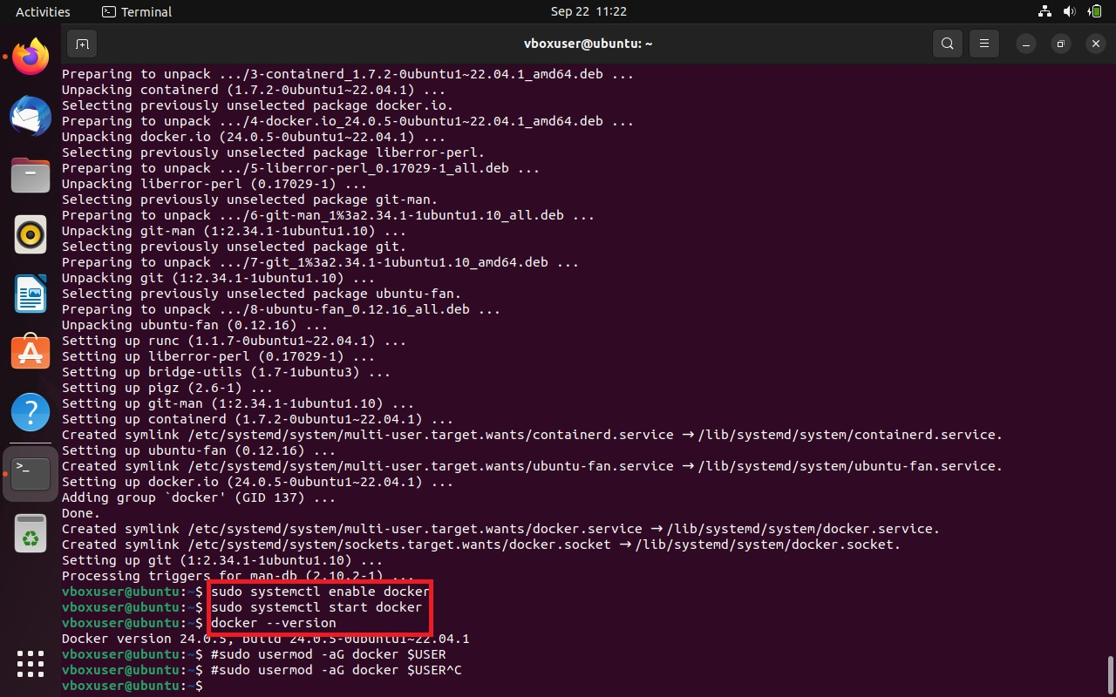

**Account Creation on Docker Hub**

**References:**

<https://www.geeksforgeeks.org/how-to-install-and-configure-docker-in-ubuntu/>